1. **Agenda**:
   1. Let’s define relationship b/w user and role entities.
2. 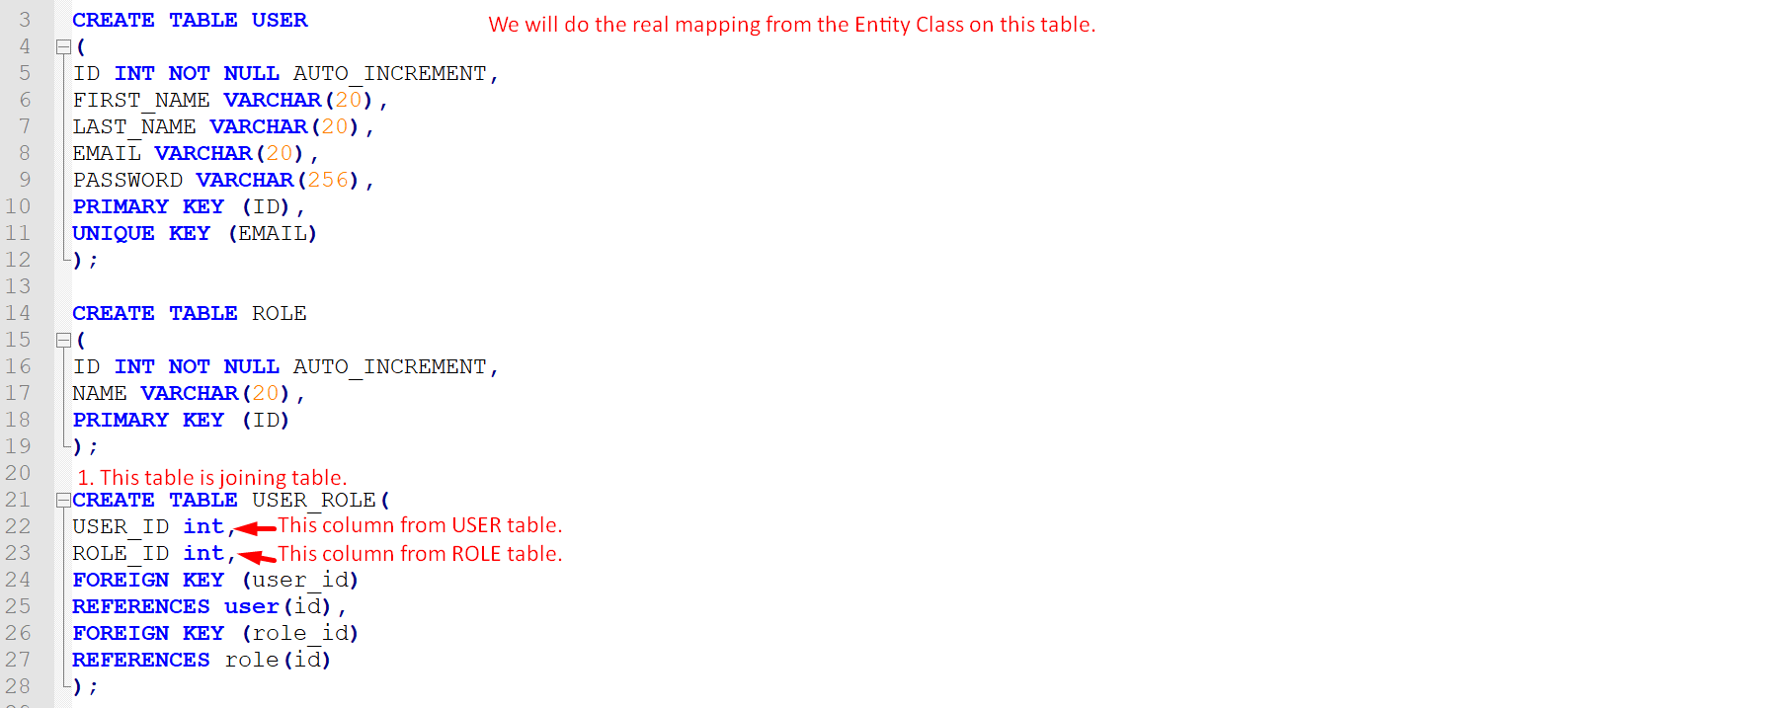
3. 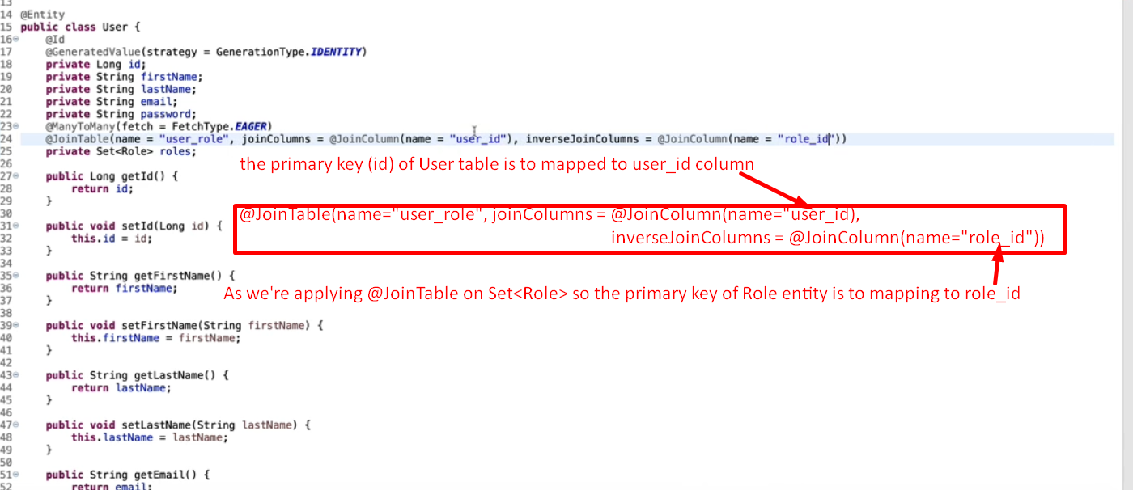
4. 